National Walkability Index Analysis
- Understand the Problem & Data
The U.S. Environmental Protection Agency (EPA) Walkability Index dataset uses Census 2019 block group data to rank areas by walkability. It includes 220,740 observations with variables about job density, street layout, transit access, and employment diversity.
For each census block, we have the activity density, which is how many housing units and jobs are in an area (denoted as D1D), employment mix which is how many different types of jobs exist (denoted as D2B_E5MIX), street connectivity which shows how well streets are connected (denoted as D3B), distance to transit/public transportation (denoted as D4A), and our response variable, Walkability. There are other variables in the dataset we will not use for our analysis. Note that in the original dataset, the dependent variable was NatWalkInd, a quantitative variable which was later converted to a binary categorical variable called Walkability, where ‘0’ represents not walkable, which is the important class in this analysis, and ‘1’ represents walkable. Block groups more than ¾ mile from transit were flagged with “-99999” to show no nearby access, which is why we removed those values to prevent strong deviations. After the removal of those values, the total number of observations dropped to 91,090.
- Walkability – binary dependent variable, converted from NatCatWalkInd, where the value of ‘0’, the important class, represents the values of NatCatWalkInd of “Least Walkable” and “Below average walkable” while the value of ‘1’ represents the values of NatCatWalkInd of “Above average walkable” and “Most walkable”.
- D1D (Activity Density) – how many housing units and jobs are in the area, where higher values represent dense, urban areas with lots of people and jobs packed, while lower values represent suburban or rural areas with fewer people and jobs spread out over more land.
- D2B_E5MIX (Employment Mix) – how many different types of jobs exist (entropy index across five employment sectors: Retail, Office, Industrial, Service, and Other), meaning diversity of job types in an area, where higher values represent jobs being evenly distributed across those categories and residents can access a variety of work opportunities nearby, while lower values represent jobs being concentrated in one sector.
- D3B (Street Connectivity) – how well streets are connected (ratio of intersections to street segments), meaning how easily people can move through a street network. High values represent grid-like street patterns with many intersections, while low values represent networks dominated by cul-de-sacs or long blocks.
- D4A (Distance to Transit) – how close residents are to the nearest public transportation stop, where higher values represent residents being far from transit stops and lower values represent residents having good access to transit stops.
The goal of this analysis is to build a classification model that predicts the walkability of a U.S. Census block group using the four listed predictors, while also identifying the most and influential variables. We apply a validation approach by splitting the data into Train and Test sets, where 80% is in the training set, and 20% in the test set.
To begin, we explored boxplots to compare activity density (D1D) and Walkability, however, its extreme skewness and large presence of outliers compressed the interquartile ranges. This led us to focus on histograms for interpretability. We can observe the plots below. The one on the left shows a raw histogram (original units) of activity density in non-walkable areas (Walkability = 0) with a heavy right skew suggesting most non-walkable areas have low activity density values and a few exteme outliers stretching far into the tail. On the right, we applied a log transformation, which shows a more balanced distribution that suggests non-walkable areas stay clustered at lower densities.
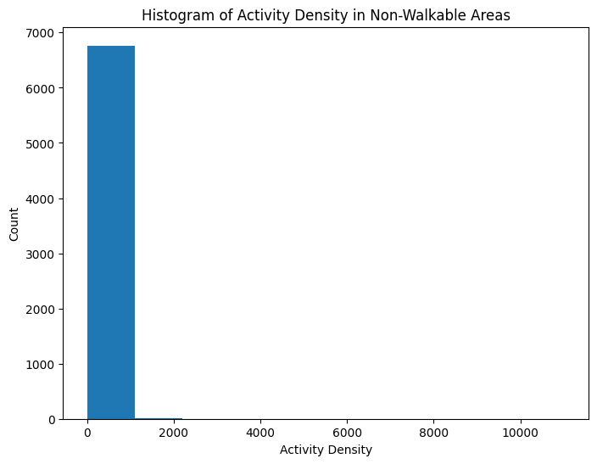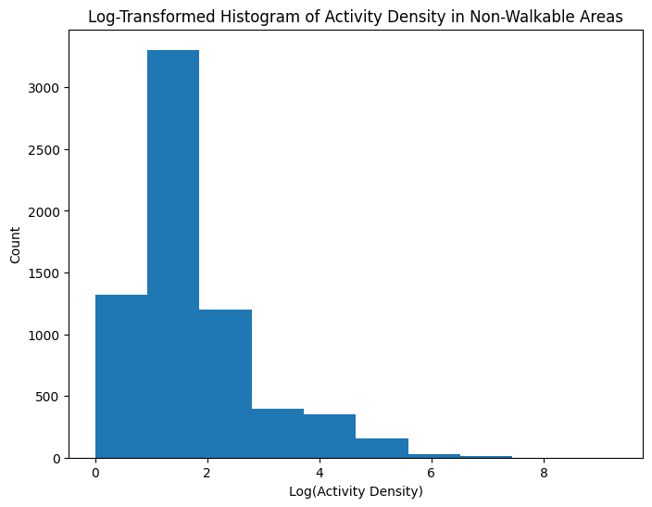

Next, we plotted the activity density histograms for walkable areas (Walkability = 1) below. The left one uses the original units, and the right one uses the log transformation. The raw histogram shows a heavy right skew, with most values concentrated at low activity density and a few extreme outliers. The log-transformed histogram the distribution is more balanced suggesting walkable areas tend to have higher and more varied activity density than non-walkable ones.
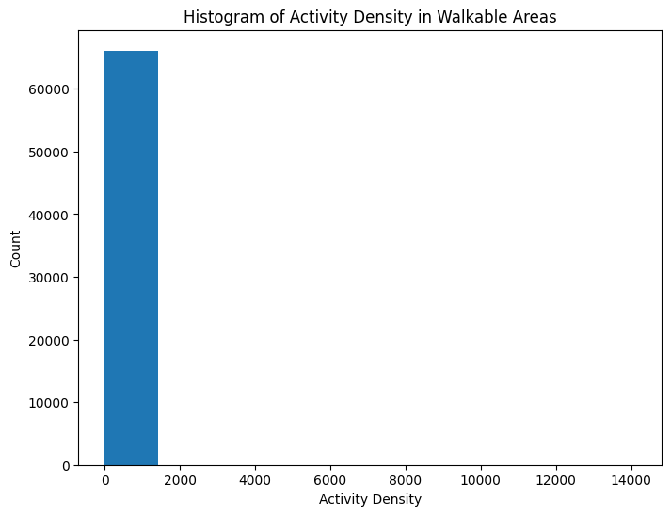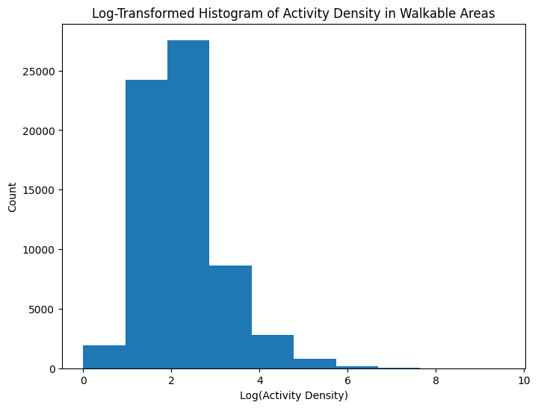
Next, we will explore the boxplot below to analyze the Employment Mix (D2B_E5MIX) vs Walkability. We can observe that the median for D2B_E5MIX is higher on walkable blocks than on non walkable ones. Non-walkable blocks however show greater variability. This could suggest that employment mix is positively associated with walkability.
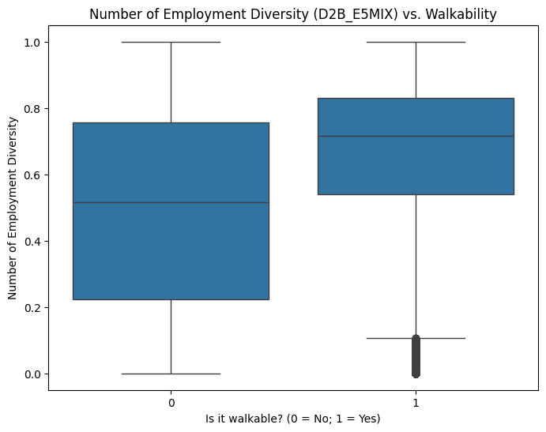

Next, we are going to look at Street Connectivity (D3B) vs. Non-Walkable Areas (left) and Walkable Areas (right). The plots suggest that non-walkable areas tend to have low street connectivity with most blocks falling in the 0-50 range, while walkable areas tend to have moderate connectivity with most values around 125.
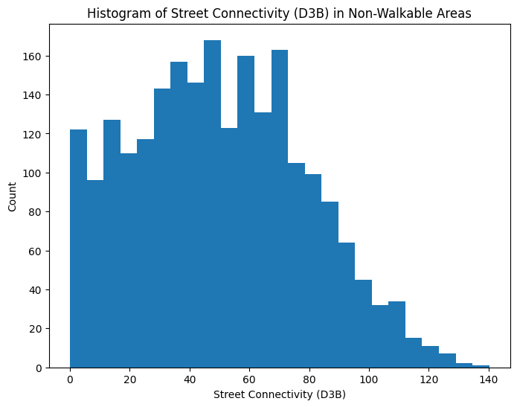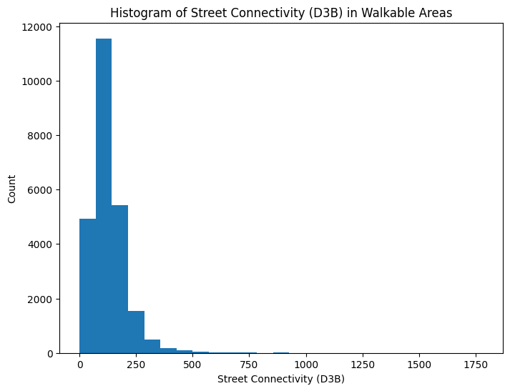
Lastly, to explore the relationship between Distance to Transit (D4A) vs. Walkability, we observe the boxplot below. Walkable areas have a lower median distance to transit with less variability, while non-walkable areas the opposite.
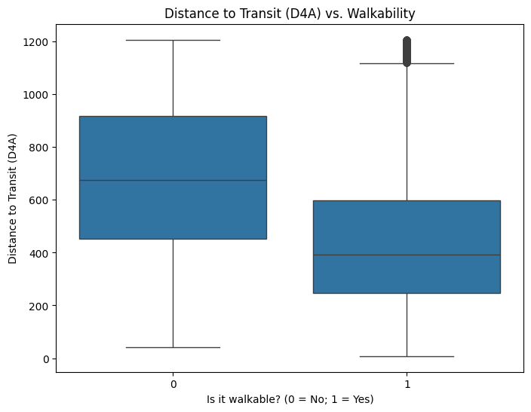

- KNN Model Specification
To predict the walkability class, we consider fitting a K-Nearest Neighbors (KNN) classification model using the following predictor variables:
- D1D (Activity Density)
- D2B_E5MIX (Employment Mix)
- D3B (Street Connectivity)
- D4A (Distance to Transit)
K-Nearest Neighbors (KNN) classifies observations based on the classes of the k closest points in the predictor space. Distance is calculated using Euclidean distance, so predictors with larger scales can dominate the calculation unless normalized.
The key parameter is k, the number of neighbors. We selected k by evaluating overall accuracy and sensitivity for the “Non walkable” class on a validation set for a range from 1 to 100.
Because KNN relies on distance metrics, we also normalized the data using StandardScaler which transforms each variable to have:
- Mean = 0
- Standard deviation = 1
This prevents high-variance predictors (especially D4A) from dominating the Euclidean distance calculation.

- KNN Model Estimation
The lineplot below shows the overall accuracy rate and the sensitivity for the non walkable class for a KNN model with original units. The maximum overall accuracy rate observed is ~0.9116 which occurs when k = 49 while the maximum sensitivity rate is ~0.5021 that occurs when k = 2. To select the optimal k, we chose the instance where Overall Accuracy + Sensitivity Rate for Important class gave the highest number, which occurred at k = 2, where sensitivity rate was ~0.4615 and overall accuracy was ~0.8557.
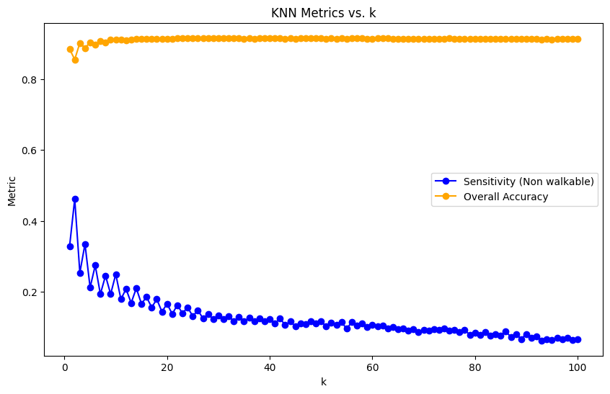
Next, the lineplot below shows the overall accuracy rate and the sensitivity for the non walkable class for a KNN model with normalzed units. The maximum overall accuracy rate observed is ~0.9341 which occurs when k = 26, while the maximum sensitivity rate is ~0.6388 that occurs when k = 2. To select the optimal k, we chose the instance where Overall Accuracy + Sensitivity Rate for Important class gave the highest number, which occurred at k = 2, where sensitivity rate was ~0.6388 and overall accuracy was ~0.8838.
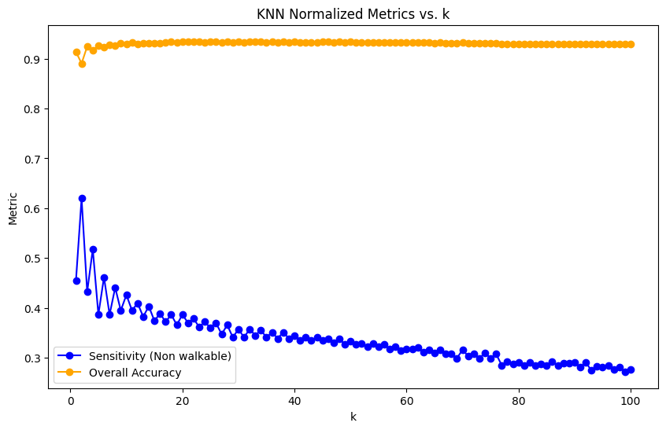
- Decision Tree Model Specification
We fit a Decision Tree classifier to predict walkability (binary outcome: walkable vs. non-walkable) using the following predictor variables:
- D1D (Activity Density)
- D2B_E5MIX (Employment Mix)
- D3B (Street Connectivity)
- D4A (Distance to Transit)
Decision Trees classify observations by recursively splitting the predictor space into regions that maximize purity. The key parameters requiring tuning are:
- max_depth: controls the maximum depth of the tree to prevent overfitting.
- ccp_alpha: the cost-complexity pruning parameter, which balances tree complexity against missclassification error.

- Decision Tree Model Estimation
We evaluated tree depths from 1 to 20, and selected the depth that maximized accuracy. The best depth was 7, with a validation accuracy of 0.9328.
The visualization of the simplified tree (depth = 3) below, displays the main decision rules, while the much larger full pruned tree captures finer distinctions. The results show that street connectivity (D3B) is the most influential predictor of walkability, followed by employment mix (D2B_E5MIX), then distance to transit (D4A), and last the activity density (D1D).
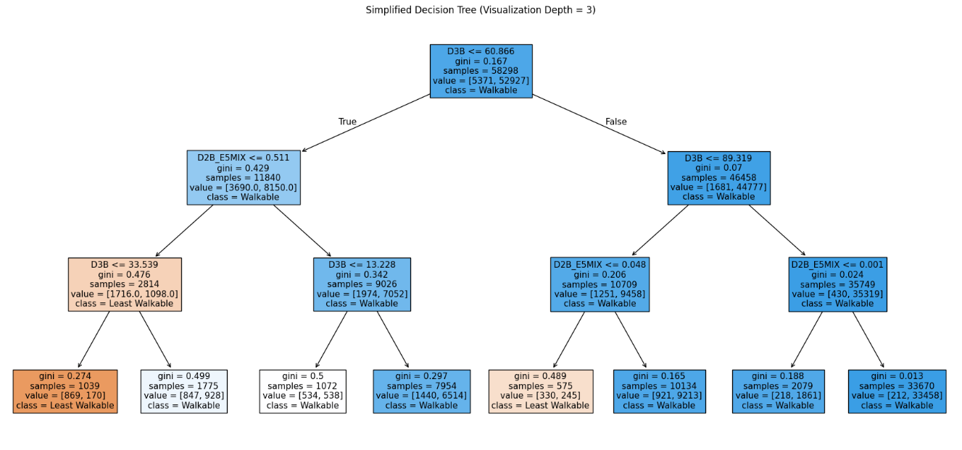
We applied cost-complexity pruning across a grid of alpha values. The optimal value that yielded the lowest missclassification error was 0.00041 as observed in the plot below.
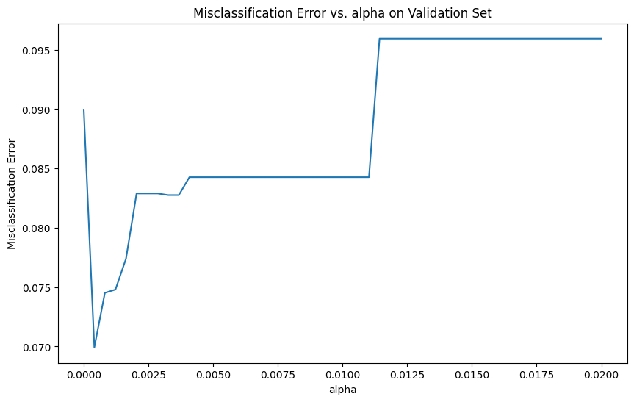
The pruned tree has a depth of 7, and 30 leaves balancing accuracy and interpretability. The feature importance scores below show the influence of the predictors:
  - D3B (Street Connectivity): 0.526
  - D2B_E5MIX (Employment Mix): 0.310
  - D4A (Distance to Transit): 0.133
  - D1D (Activity Density): 0.030

- Bagged Tree Model Specification
To predict walkability class, we consider fitting a bagged tree model using all four predictor variables.
In bagging, each tree uses all predictors at every split, which matches our implementation using a BaggingClassifier with fully grown trees (max_depth = None) and the default max_features setting for regression. The only parameter that requires tuning is n_estimators.
- Bagged Tree Model Estimation
Using a 3-fold cross validation we selected n_estimators = 100 as the optimal parameter. This resulted in a validation accuracy of 0.9350. As we can observe on the bar chart on the image below, the fitted bagged tree model indicates that D3B (Street connectivity) is the most important predictor with a high importance score of 0.3487, while D1D (Activity density) as the least important with an importance score of 0.1643.
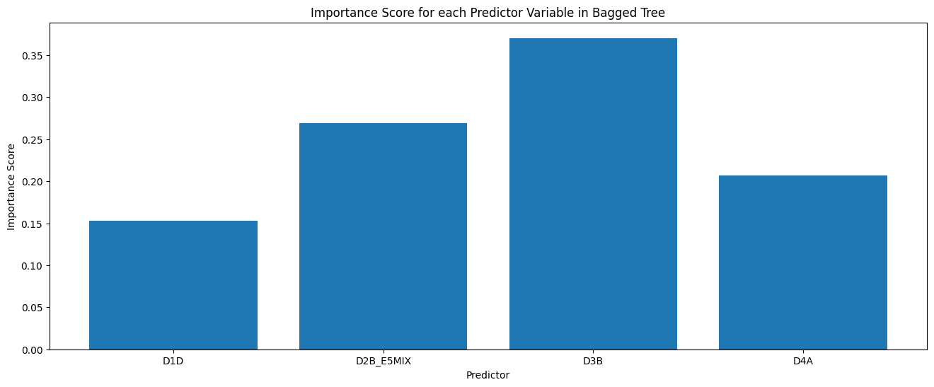
- Model Specification II: Random Forest
We will set max_features = “sqrt”, which means that at each split in a tree, only a random subset of predictors equal to the square root of the total number is considered. This helps increase model diversity and helps reduce overfitting.
We will tune the parameter n_estimators, which controls the number of trees in the forest. All other parameters were left at their default values in this analysis.

- Model Estimation II: Random Forest
Using a 5-fold cross validation we selected n_estimators = 1000 as the optimal parameter. As we can observe on the bar chart on the image below, the fitted random forest model also indicates that Street Connectivity (D3B) is the most important predictor with an importance score of 0.3350, while Activity Density (D1D) as the least important with an importance score of 0.1987.
Compared to the bagged tree in Model Estimation I, the random forest shows a more balanced distribution of importance scores across the different predictors due to the random feature selection at each split, which increases the model diversity and reduces overfitting.
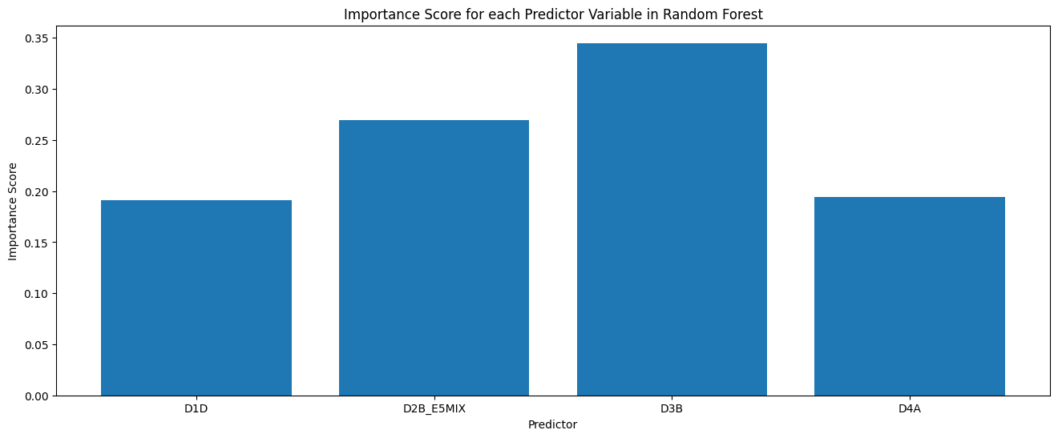
- Model Assessment
The overall accuracy rate, which shows how accurate are a model’s predictions, on both the training and testing data for each model are as follows:
- Original KNN: Training accuracy = 0.942, Test accuracy = 0.850 [lowest]
- Normalized KNN: Training accuracy = 0.954, Test accuracy = 0.894
- Decision Tree Pruned: Training Accuracy = 0.9349, Test accuracy = 0.9366
- Random Forest: Training Accuracy = 0.9511, Test accuracy = 0.9371
- Bagged Tree: Training Accuracy = 0.9867, Test accuracy = 0.9386 [highest]
The sensitivity rate for the Important Class (Non Walkable), which shows how good a model is at identifying the non walkable areas, are as follows:
- Original KNN: Training sensitivity = 1.0, Test sensitivity = 0.495
- Normalized KNN: Training sensitivity = 1.0, Test sensitivity = 0.6590 [highest]
- Decision Tree Pruned: Training sensitivity = 0.4784, Test sensitivity = 0.4603 [lowest]
- Random Forest: Training sensitivity = 0.6191, Test sensitivity = 0.4903
- Bagged Tree: Training sensitivity = 0.8963, Test sensitivity = 0.5128
Based on our goal which is predicting the walkability class, we recommend proceeding with the Bagged Tree for model deployment since it achieves the highest overall accuracy rate on the testing data (0.9386), while maintaining a reasonable sensitivity rate for the important class on the testing data (0.5128). If the primary goal was to identify the non walkable areas specifically, the Normally KNN offers the strongest test sensitivity (0.6590).

- Model Deployment
We considered a predictor profile that utilizes the mean of each predictor variable from the full dataset (clean_smart):
- D1D: 11.8252
- D2B_E5MIX: 0.6382
- D3B: 121.6903
- D4A: 497.9899
Utilizing this profile, the bagged tree model predicted this to be Walkable with 100% model confidence. This could suggest that an average U.S. Census block group in our dataset are generally walkable and that our model is reliable.
Next, for a more interpretable model, we built a decision tree on the full clean dataset with 8 terminal nodes.
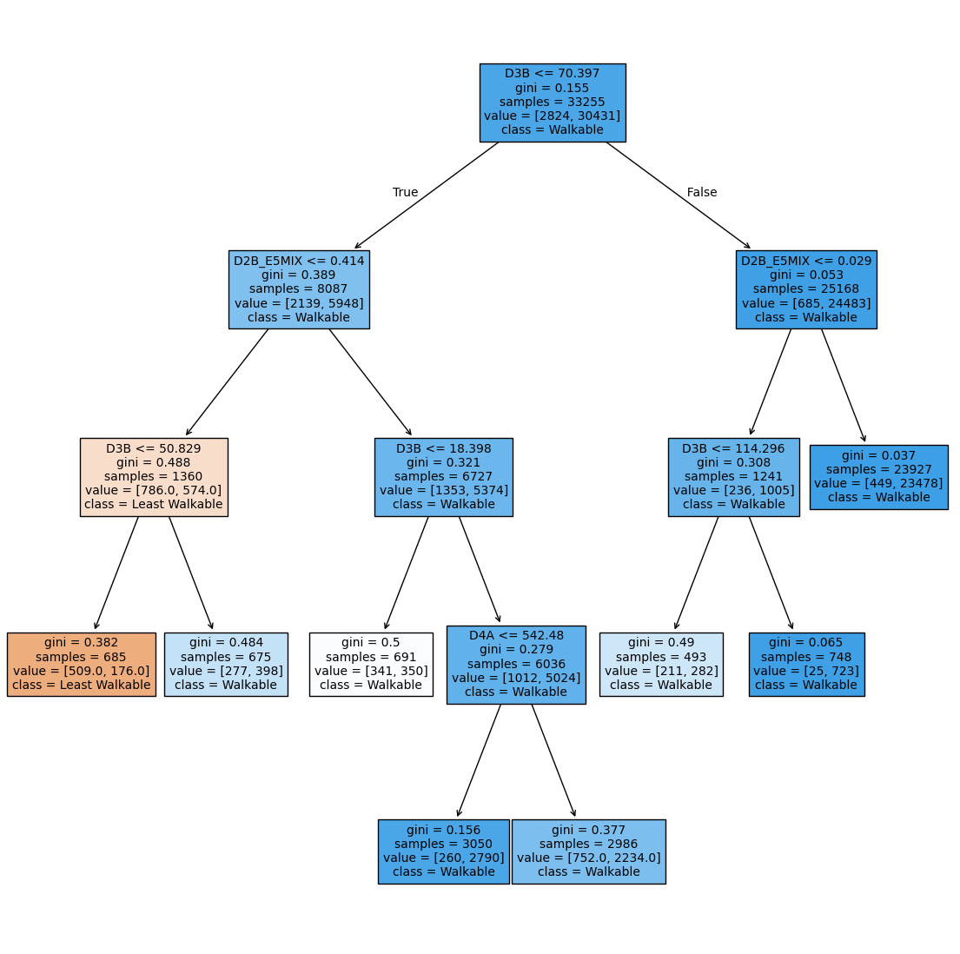
The tree provides the following insights:
- If Street Connectivity (D3B) ≤ 70.397, walkability depends on Employment Mix (D2B_E5MIX).
- Low Employment Mix (D2B_E5MIX) with very low Street Connectivity (D3B), ≤ 50.829 or ≤ 18.398 non-walkable.
- If D3B > 70.397, blocks are consistently Walkable.
- Higher Street Connectivity (D3B) improves walkability especially when Distance to Transit (D4A) ≤ 542.48.
- Activity Density (D1D) does not appear, suggesting weak influence in this tree.

- Generative AI Assessment:
Tool Used: ChatGPT - 4
Task Description: Assist me in what plots to use for EDA as well as in adjusting my Decision Tree, Bagged Tree, and Random Forest models to my dataset. This also included how to enhance my output so it includes everything that I could need (like number of leaf nodes, accuracy rate, etc.)
Prompts:
- Suggest me plots to show the relationships for EDA
- Help interpret model outputs (Bagged Trees, Random Forest, KNN, Decision Tree)
- What is wrong with this code?
- Why does my code take so long? How can I make it run quicker?
Verification and Refinement Process: reviewed the outputs for accuracy by comparing with my Google Colab output (parameter values, accuracy and sensitivity rates, importance scores).

